**Otirasor Beach Resort Monitoring System**

**using GPS**

Group Members

Repas. Christian G.

Alabado, Marisol

Tia, Mark Niel

**LIST OF FIGURES**

Figure 1. Object-Oriented SDLC Model……………………………………………………..

Figure 2. Context Diagram of Otirasor Monitoring System using GPS……………………

Figure 3. Data flow diagram of developed System………………………………………..

Figure 4. Use Case Diagram of the Proponents Developed System………………………

Figure 5. Rent Activity Diagram of the Developed System……………………………………….

Figure 6. Customer Bill Process Activity Diagram of the Developed System........................

Figure 7. Customer Bill Activity Diagram of the Developed System…………………………

Figure 8. Manage Information Records Activity Diagram of the Developed System………..

Figure 9. Decomposition Chart of Otirasor Monitoring System using GPS……………

Figure 10. Entity Relationship Diagram of the Proponents Developed System………….

**LIST OF TABLES**

Table 1. Resort Monitoring System using GPS features comparison table of Related Application and System………………………………………………………………………………………….

Table 2. Rent………………………………………………………………………………………..

Table 3. Customer Information…………………………………………………………

Table 4. Monitoring………………………………………………………………………………

Table 5. Manage Information Record…………………………………………………………….

Table 7. Customer………………………………………………………………………………….

Table 8. Personnel…………………………………………………………………………………...

Table 9. Admin……………………………………………………………………………………..

Table 10. Boat………………………………………………………………………………………

Table 11. Log in……………………………………………………………………………………..

Table 12. Information Record………………………………………………………………

**Chapter I**

**INTRODUCTION**

Now a day’s technology is a booming market full of exciting and innovative products and new learning opportunities. With technology as a major consumer of our time and also an exciting experience in our world today, pare you motivated to generate something new? (By: Kendall Bird)

GPS technology is the most commonly used in businesses for the monitoring purposes in order for them to track the movement of the sea vehicles and this technology has a lot of features beyond its capability, it is essential because it tracks all the activities of the customer. This technology is a navigational system that uses signals from satellites to tell you were you are and give you directions to other places.

The study examines the task of learning to develop a cost-effective sea vehicle movement that could use to monitor and to track the vehicle automatically, using the Global Positioning System (GPS). As for the Resort`s owner could lessen the risk for the safety of the customers in riding the sea vehicles. GPS is more useful applying it in a Resort`s Sea Vehicle Monitoring System as it allows the management more efficient in monitoring or tracking their sea vehicles.

**General Objectives**

This study aims to develop a Resort Sea Vehicle Monitoring System that allows the Resort Management to track their customers riding the sea vehicles, providing the management in securing the safety of the customers in their sea expenditures.

**Specific Objective**

1. To develop a safety precaution for the customer riding the vehicle.
2. To manage an automatic monitoring of sea vehicles.
3. To secure the safety of a customer riding a sea vehicle.

2.) To evaluate the system using the following criteria:

1. Functionality
2. Usability
3. Efficiency
4. Portability
5. Reliability
6. Maintainability

**Purpose and Description**

The safety of the customer is the goal of most resort owners during sea venture activities, and we cannot predict if accident happen during the ventures. So to solve this issue the proponents aimed to develop a system that could lessen the threats or harm to the customers.

The Proposed System is a Resort Monitoring System that uses GPS technology. This system has a feature that the customer can ask for help if they are need for rescue. This system uses GPS device installed to the sea vehicle in order for the system could track the vehicle. The system has a GPS Server that accessible by mobile devices so that the Resort Management could monitor the sea vehicles even he/she doesn’t at the server room.

**Scope and Limitation**

Lots of work has already done in the field of location base service & the advancement of technology that helps to create more user friendly location base applications. Using GPS technology, the proponents made the project based on the needs or how the system affects to the businesses for monitoring purposes, most especially to the resort owners. Moreover, the system that been proposing in this project have the following usefulness: This application will help the management monitor their customer for the resort business., Customer could not worry about their safety because the vehicle is tracked all the time., Resort management can monitor the vehicles using mobile or tablet., The system is generated by a GPS Server.

The system has a lot of features but yet has its own limitations: The system is only applicable for the resort businesses. The system could accommodate by the resort management only or the authorized personnel’s., the system can be only used inside the resort where the mobile or portable devices is connected to the LAN network.

**Significance of the study**

This project is significant and beneficial to the following:

* ***Customer*** – this system is great advantage to the customer regarding to their safety, allowing them to freely enjoy the sea adventures at the beach without any harm.
* ***Future Researchers –*** the system could benefit the next generation and helps them to develop their works specially in getting some related studies.
* ***Researchers –*** can be used as cited references and relate to the proposed system and improve the current system development.
* ***Resort Management***– the system will provide them an automated monitoring that allow them to track their customer riding on a sea vehicle with the use of GPS.

**Definition of Terms**

For the clarification of the common understanding, the key word has been used in this study will be defined as follow:

**GPS –** a navigational system that uses signals from satellites to tell you where you are and to give you directions to other places.

In this study, the GPS device was attached to the vehicle that gives a navigational status about the location of the customer for monitoring purposes.

**GPS Server –** is a powerful and easy to use GPS tracking system that allows you to monitor the location of vehicles, cargo, boats and people. It can be cloud hosted where you log in to the service with you mobile or compatible GPS device or it can be installed in your own server.

In this study, the GPS Server is the one that receives the signal from the GPS device to know the location of the monitored vehicle.

**Monitoring –** to watch, observe, listen to, or check (something) for a special purpose over a period of time.

In this study, this term is used in observing the movement or progress of the customer riding the vehicle.

**Sea Vehicle –** marine vessel are water-borne vehicles including ships, boats, hovercraft, and submarines.

In this study, the sea vehicle is used to ride by the customer in performing sea activities.

**Chapter II**

**Review of Related Literature and System**

This chapter discussed the foreign and local system related to the study of Title. This will serve as the basis on how the proponent develop their system, gives the overview of previous study that help the proponent to in sight the related system between their plan to the existing system, to gather some ideas and applying it to the project.

**Related Concepts**

The proponents conducted a research with the use of books and internet to provide related literature and prior arts system that are applicable in the development of the system.

**Local Prior Arts**

**MMDA Accident Alert**

According to The Metro Manila Development Authority (MMDA) brings Accident Alerts for Android- the user’s handy guide in navigating through Metro Manila’s traffic. Be able to avoid floods, traffic and road hindrances with easy and amazing application. The MMDA Accident Alerts has the ability to view the latest advisories from MMDA in line view and map view. The user can also get notification about recent advisories to their destination in real-time, and includes major thoroughfares in these routes EDSA Commonwealth, Quezon Ave, Espana CS, Ortigas, Marcos Highway, Roxas Blvd, ELEX, NLEX (MMDA, 2014).

The system is related to the Sea Vehicle Monitoring System by giving people a safety precaution to avoiding them in harm. Provide an accident alert to the passengers or costumer.

**Manila Map and Walking Tours**

Manila Map is handy application present several self-guided walking tours

To see the best of the Manila, Philippines, and it comes with detailed tour route maps and powerful navigation features to guide users from one sight to the next. No need to hop on a tour bus or join a tour group; now users can explore all of the best attractions on your own, at your own pace, and at a cost that is only a fraction of what you would normally pay for a guided tour (Manila 2016)

It is similar to the proposed system of the proponents because the Manila Map and Walking Tours can guide users on their destination using a map and the feature of giving detailed information about the place.

**Foreign Prior Arts**

**NAVSTAR Global Positioning System**

According to the Defense Department combined its competing satellite navigation systems. The new joint program under the Air Force was called the NAVSTAR Global Positioning System, or GPS. It introduced synchronized time from space, provided by onboard atomic clocks. The system was intended for a range of military applications,

including locating ships and targeting weapons. GPS designers envisioned that civilians would use the system as well. (Defense Department, 1973).

The system is related to the Sea Vehicle Monitoring System because of the satellite navigation system. It locates ships and targeting weapons.

**Iran GPS**

Iran GPS is a local navigation application for iOs with user-friendly interface and powerful function. It is available on iPhone and iPad. The user can use this application when driving a car, ride a bike or walk to their destination. This application provides local search and offline navigation when the user travel or live in China. Some advanced technology such as vector map, shortest path algorithm, offline address database is adopted. Vector map features high quality and much smaller size. Address database combining both online and offline data provide rich POIs (Point of Interest). Built-in electronic compass can assist to judge the direction of route. This application is completely offline map and navigation, work without connection or data forming which helps the user to save money. This application is switchable from 2D to 3D, switching English/local language map display. It has a professional navigation raging with fast routes turn by features makes you to enjoy a good navigation (*JING Li,* 2014).

The Application has a similarity to the proposed system because it is offline map that available on iPhone and iPad. Has a professional navigation raging with fast route.

**Synthesis of Related Literature**

The comparison below shows the different features of the proposed system that was compared to the Otirasor Beach Resort Monitoring System using GPS. This table of comparison is composed of features possessed by every system on the internet.

Table 1. Features and comparison of foreign and local system

|  |  |  |  |  |  |
| --- | --- | --- | --- | --- | --- |
| **Related Prior Arts** | **Features** | | | | |
|  | **Portability** | **Connectivity** | **Monitoring** | **Navigation** | **Security** |
| MMDA Accident Alert | **Yes** | **Online** | **No** | **Yes** | **Yes** |
| Manila Map and Walking Tours | **Yes** | **Online** | **Yes** | **Yes** | **No** |
| NAVSTAR Global Positioning System  Iran GPS | **Yes**  **Yes** | **Online**  **Online** | **Yes**  **Yes** | **Yes**  **Yes** | **No**  **Yes** |
| Monitoring System of OBR | **Yes** | **Online/Offline** | **Yes** | **Yes** | **Yes** |

**Local Related Literature**

**Calamity Guide**

The users have to enable their GPS/Location services and users also need access to data connection or Wi-Fi. However, if the user’s mobile data or Wi-Fi is not available they can still access offline features like tips, emergency kit, and emergency SMS. The emergency alert maps are accessible to everyone but only people living in Binalbagan can currently use the alert feature on the map (Tanchico, 2016)

The system is related to the Sea Vehicle Monitoring System using GPS for Otirasor Resort because they have an emergency alert map that accessible to everyone but only costumers inside the resort can currently use the alert map.

**GPS Phone Tracker Probe Family Safety Production**

GPS Phone Tracking Pro uses GPS coordinates and state-of-the-art GPS location data to report the real-time where about of your friends. You can monitor your friends travel from one location to another via the apps GPS maps. This is very helpful features when you’re traveling separately from a friend who has a tendency to get lost often. It can pinpoint the location of registered mobile devices, smartphones and even old school features phones via the apps website, 24/7. Its state-of-the-art GPS system can keep tabs on registered phones, using satellites to triangulate the exact location for every phone registered to your account. This versatile phone locator also offers printer-friendly directions to the misplaced phones location.

This Application is similar to the proposed system because it is a very helpful and useful when you’re traveling separately from a friend who has a tendency to get lost often. Has a phone locator that in case of emergency you can fast to locate your friend.

**Foreign Related Literature**

**Vessel Monitoring System**

According to the Australian Fisheries Management Authority(AFMA), has been using VMS technology to monitor fishing boats since 1993 and the new trackwell solution will assist in managing the activity for thousandths of commercial fishing vessels to support both commonwealth and selective state and territory fisheries agencies within the third largest Exclusive Economic Zone(EEZ) in the world. The trackwell VMS will support AFMA and partner agencies to ensure continuous compliance with fisheries management regulation (AFMA, 1993).

This system has been using VMS technology to monitor fishing boats and tracking all the fishing vessel if they go far from their location, where it is related to the proposed system that uses GPS device to track their customers.

**Seoul Bus 3 - Metropolitan Bus**

Seoul Bus provides local bus information for the greater Seoul metropolitan area not only all regions of Seoul, but also for Incheon and areas of Gyeonggi- do nearby. Via

Internet access and real- time data, users can determine where a bus is right now or when a particular bus will arrive at a particular stop.

Offline usage provides users with the ability to determine bus numbers, routes and stops. In addition, nearby bus stops can be located and with the map, any station can be searched for and found. When locating nearby stops, the iPhone utilizes GPS technology and is very accurate, whereas the iPad Touch relies on Wi-Fi which is not as efficient and may result in slight relative errors. Bus stop names are displayed in Korean but the stops

Unique ID number- 5 digits with a dash can be conveniently used with the search function (*Juwan Yoo,* 2015).

The Seoul Bus 3-Metropolitan Bus has a feature of real-time monitoring were the customer could determine where a bus is right now or when a particular bus will arrive at a particular stop. This feature is related to the proposed system that also using a real-time monitoring that determines for the scheduling of the sea vehicles.

**Table of Comparison**

The table shows the list of the prior system both foreign and local systems and different features that compare on the features of Resort Monitoring System using GPS.

Table 1. Resort Monitoring System using GPS features comparison table of Related Application and System.

|  |  |  |  |  |  |
| --- | --- | --- | --- | --- | --- |
| **Related Prior Arts** |  | **Features** |  |  |  |
|  | **Portability** | **Connectivity** | **Monitoring** | **Navigation** | **Security** |
| Calamity Guide | **YES** | **ONLINE** | **NO** | **YES** | **YES** |
| GPSPhone Tracker ProbeFamily Safety Production | **YES** | **ONLINE** | **YES** | **YES** | **YES** |
| Vessel Monitoring System | **YES** | **ONLINE** | **YES** | **YES** | **NO** |
| Seoul Bus 3 - Metropolitan Bus | **YES** | **ONLINE/OFFLINE** | **YES** | **YES** | **NO** |
| Monitoring System of OBR | **YES** | **ONLINE** | **YES** | **YES** | **YES** |

**Conclusion:**

Table 1 shows the comparison of related application and system, this shows what are the existing application and system that can be compare to develop the project. This includes their features such as connectivity, monitoring, GPS, and security

**Chapter III**

**Methodology**

This chapter presents the research design and methodology of the proponents system.

**SDLC**

The proponents used Agile Methodology to as guided to the proponents in developing the system to meet the satisfaction of the user and constructing the software development. Agile Method use incremental, and it is known sprints it is a time period to allocate the particular phase of a project. This method is the most fitted methodology for our proposed system.

**System Development Life Cycle**

The Agile Method is a particular approach to project management that is utilized in software development. This method assists teams in responding to the unpredictability of constructing software. It uses incremental, iterative work sequences that are commonly known as sprints. Many of the agile ideas surfaced in the 1970s. Studies and reviews

Were conducted on the Agile Method that explains its emergence as a reaction against traditional approaches to project development.

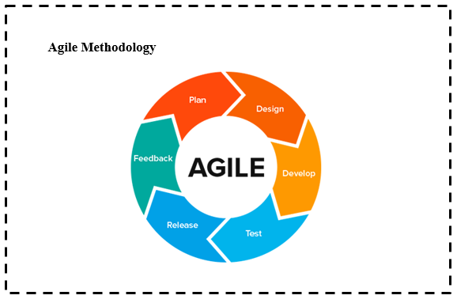

**Figure 1:** displays the processes of software development that should be done in order to reach the satisfactory level of the system. The Agile methodology (Software) Development Life Cycle has six important steps needed to be encompassed in order to produce a full-developed system.

**Plan**

The existing monitoring process of Otirasor Beach Resort is less effective in terms in monitoring the customer on their sea activities. They uses only a two way radio for communication and a record book as a references. So the proponents planning on how

To increase the efficiency of the system, gather all the information needed, and to provide the resort an efficient system that can cover the full operation in monitoring the resort.

**Design**

The proponents consider the analyzed specification and requirements of the resort applying it to the system that has an understandable design, and could meet the expectations of the user.

**Develop**

The proponents apply the analyzed specification and requirements of the system, generation of codes or program, together with the system design.

**Test**

If all the procedures and operation was done, system testing is necessary to know the bugs and errors of the proposed system as a step before releasing.

**Release**

The proponent’s bugs and errors right after the testing period of the system, finalizing the program codes and getting ready the system for release.

**Feedback**

The proponents needs the feedback of the customer and the clients as a basis we there the program is effective according to its uses, proper evaluation for the updates of the program, and maintaining the efficiency and enhancement of the program.

**Context Diagram**

The context diagram shows the general flow of processes of the developed system where an entity concerned is connected to a one main process. It also portray the general input requirements and its processed output.

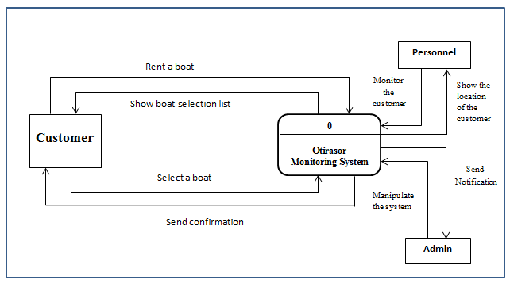

Figure 2.Context Diagram of Otirasor Monitoring System using GPS

Figure 2 shows the general processes of the developed system. It also demonstrates the input requirements needed to be filled-up by the administrator and the expected processed output from the system.

**Data Flow Diagram**

The data flow diagram illustrates the flow of data in database and the process from the customer to the admin.

Figure 3. Data flow diagram of developed System.

**Use Case Diagram**

The use case diagram shows the user’s interaction with the system and its relationship between the different use cases and the user is involved.

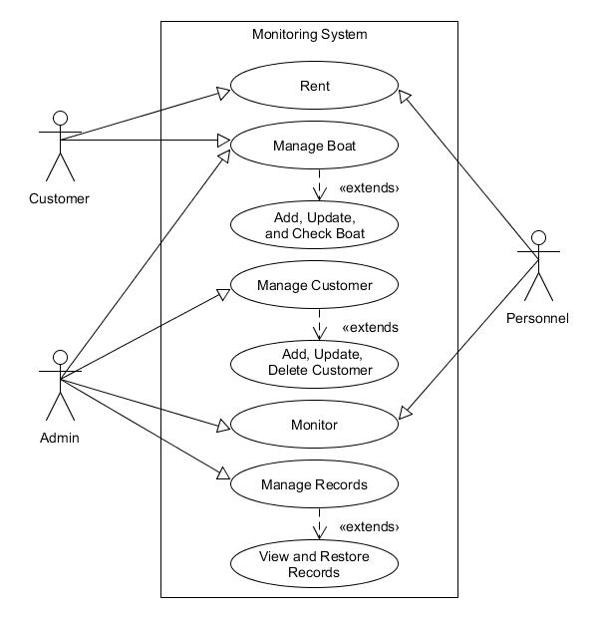

**`**Figure 4. Use Case Diagram of the Proponents Developed System

Figure 4. Show the major tasks that actor must be done in order to implement the system. As the figure shows, the customer is must

**Use Case Description**

The Table below describes the function, conditions and alternative flows to be met of all entities used in the use case diagram.

Table 2. Rent

|  |  |
| --- | --- |
| Use case name | Rent |
| Actors | Personnel, Customer |
| Descriptions | This use case describes how the customer rent a sea vehicle associated with the personnel. |
| Pre-conditions | Personnel – must encode the customer information and selected vehicle with the use of mobile/tablet/Ipad.  Customer – must comply the requirements. |
| Post-conditions | Personnel – submit the information to the system.  Customer – wait for the process. |
| Main success scenario | Customer – Rented a sea vehicle.  Personnel – Submitted the customer information to the system. |

|  |  |
| --- | --- |
| Use case name | Manage Boat |
| Actors | Customer, Personnel |
| Descriptions | This use case describes the management of Boat. |
| Pre-conditions | Customer – Must select a boat to be rented.  Personnel – Must check the boat if it is available. |
| Post-conditions | Customer – wait for the process.  Personnel – confirm the selected boat. |
| Alternative flow | Personnel – if there`s no available boat, he must wait for the available boat, or reserve the selected boat by the customer. |
| Main success scenario | Customer – get the desired boat.  Personnel – done the process. |

Table 3. Customer Information

|  |  |
| --- | --- |
| Use case name | Monitor Customer |
| Actors | Admin, Personnel |
| Descriptions | This use case describes the monitoring of Customer |
| Pre-conditions | Admin – check the online customers.  Personnel – accompany the admin. |
| Post-conditions | Admin – monitor the location of the customer.  Personnel – communicate the admin about the status of the customer, using a two way radio. |
| Alternative flow | Admin – if something is wrong with the customer, he should notify the personnel to rescue the customer. |
| Main success scenario | Admin – secured the safety of the customer.  Personnel – the customer was until he/she come back or done for the activity. |

Table 4. Monitoring

|  |  |
| --- | --- |
| Use case name | Manage Records |
| Actors | Admin |
| Descriptions | This use case describes the management of Records. |
| Pre-conditions | Admin – Gather all the information. |
| Post-conditions | Admin – Save all the information. |
| Main success scenario | Admin – all the information was saved. |

Table 5. Manage Information Record

**Activity Diagram**

Activity diagram shows the activities done in each of the entities being performed during the process of the system.

Figure 5: Rent

Personnel

Customer

Entertain the customer

Rent a sea vehicle

Give the selection of the available sea vehicle

Select a sea vehicle

Get the selected sea vehicle

Ready the sea vehicle selected

Figure 6: Customer Information

Personnel

Customer

Entertain the customer

Rent a sea vehicle

Give the selection of the available sea vehicle

Select a sea vehicle

Get the selected sea vehicle

Ready the sea vehicle selected

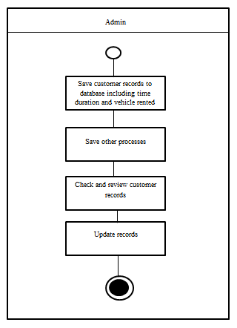Figure 7: Monitoring

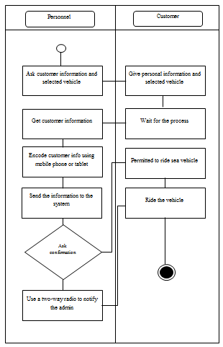Figure 8. Manage Information Records

**Decomposition Chart**

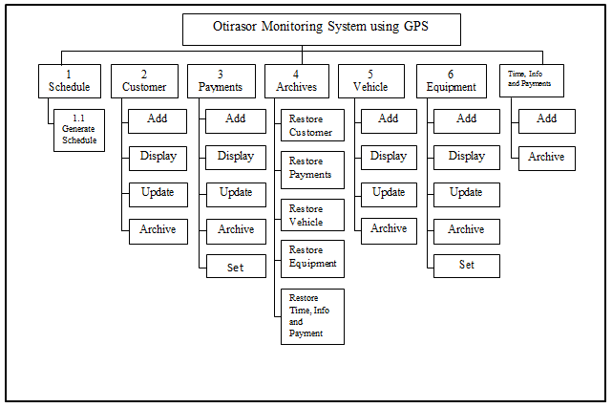 Decomposition Chart shows the break down process and its sub-processes of the whole system.

Figure 9. Decomposition Chart of Otirasor Monitoring System using GPS

Figure 9 shows the break down process and its sub-processes of the whole system. Every process is labeled and mark one-by-one to equate the functionality of whole process system.

**Entity Relationship Diagram**

Relational database management system (RDBMS) is a database management system (DBMS) based on relation model of data. In conformity, the Entity Relationship Diagram shows the relationship and the connection of all tables in the database in a working system.

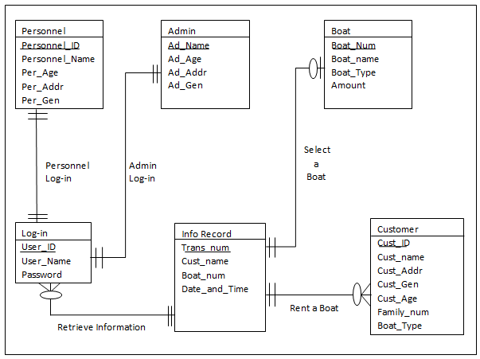

Figure 10. Entity Relationship Diagram of the Proponents Developed System

**Operational Framework**

The workflow in using the Otirasor Monitoring System using GPS is composed of Satellite, Server, ADSL Router . It is stored in the database and retrieves from the database.

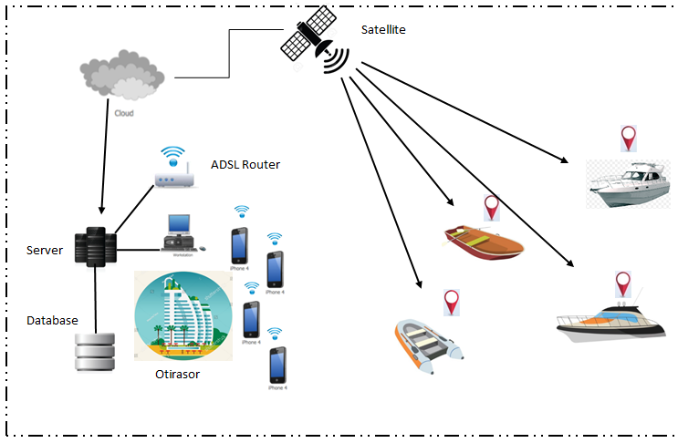

**Hardware Requirements**

The proponents had used the hardware requirements that were applicable for the systems application development and maintenance. The

**For Development:**

**Hardware Specification:**

**(Sea vehicle monitoring of Otirasor Beach Resort using GPS technology could run in its most efficient quality if you have this following recommended hardware specification.)**

* At least 200 GB Hard drive
* At least 2 GB RAM
* At least i1/1.2GHz Processor
* 32 / 64 bit computer
* LCD Monitor
* Mouse
* Keyboard

**Recommended Network and Communication Device**

* N300 wireless ADSL + 4 port Wi-Fi
* UTP Cat5e
* GPS Device

**Recommended Software Specification (Server/Work Station)**

* Windows Server 2008 Enterprise Edition(windows 7 or higher)
* A backup utility software
* Microsoft Access Database
* Crystal Report
* Visual Basic 2012
* NetBeans IDE
* Eclipse
* Heidi SQL
* Xampp

**Time Table**

The time tables represent the sequence of the task and duration of which the task will take to be completed. Preparing the task and its duration provide the proponent approximate schedule of the project making to reach the time of the accomplished project. This table helps the proponents to organize the details of the project.

**Gantt chart**

The Gantt chart assesses the proponents with the project management throughout the whole process. It caters of how long the process will take that allow time management effectively. The minimum delivery time of this project was being figure out means of Gantt chart.

**Data Dictionary**

The tables below shows the list of all tables and the data stored in the database of the Monitoring System of Otirasor Beach Resort. It provides the attribute, data types and also the description for each fieldnames to recognize the data being stored in the database.

Table 7: Customer

|  |  |  |  |
| --- | --- | --- | --- |
| **Fieldname** | **Description** | **Type** | **Length** |
| Cust_ID | Customer ID | Int | 5 |
| Cust_name | Customer Name | Varchar | 20 |
| Addr | Address | Varchar | 50 |
| Gen | Gender | Varchar | 20 |
| Age | Age | Int | 3 |
| Fam_name | Family Name | Varchar | 20 |
| Boat_type | Boat Type | Varchar | 20 |

Table 8: Personnel

|  |  |  |  |
| --- | --- | --- | --- |
| **Fieldname** | **Description** | **Type** | **Length** |
| Per_ID | Personnel ID | Int | 5 |
| Per_Name | Personnel Name | Varchar | 20 |
| Per_Age | Personnel Age | Int | 3 |
| Per_Addr | Personnel Address | Varchar | 50 |
| Per_Gen | Personnel Gender | Varchar | 20 |

Table 9: Admin

|  |  |  |  |
| --- | --- | --- | --- |
| **Fieldname** | **Description** | **Type** | **Length** |
| Ad_Name | Admin Name | Varchar | 20 |
| Ad_Age | Admin Age | Int | 3 |
| Ad_Add | Admin Address | Varchar | 50 |
| Ad_Gen | Admin Gender | Varchar | 10 |

Table 10: Boat

|  |  |  |  |
| --- | --- | --- | --- |
| **Fieldname** | **Description** | **Type** | **Length** |
| Boat_Num | Boat Number | Int | 4 |
| Boat_Name | Boat Name | Varchar | 20 |
| Boat_Type | Boat Type | Varchar | 20 |
| Amount | Amount | Amount | 6 |

Table 11: Log in

|  |  |  |  |
| --- | --- | --- | --- |
| **Fieldname** | **Description** | **Type** | **Length** |
| User_ID | User ID | Int | 5 |
| User_Name | User Name | Varchar | 20 |
| Password | Password | Varchar | 10 |

Table 12: Information Record

|  |  |  |  |
| --- | --- | --- | --- |
| **Fieldname** | **Description** | **Type** | **Length** |
| Trans_Num | Transaction Number | Int | 5 |
| Cust_Name | Customer Name | Varchar | 20 |
| Boat_Num | Boat Number | Int | 5 |
| Date_Time | Date and Time | DATE |  |

**Screen Layout Design**

The screen layout of the Otirasor Beach Resort Monitoring System using GPS gives the users an overview on what they can expect on the system. This can help for them to familiarize the syste9m and also provide support in the development of the project.

**TABLE OF CONTENTS**

TABLE OF CONTENT………………………………………………………………..

LIST OF FIGURES…………………………………………………………………….

LIST OF TABLES……………………………………………………………………..

**CHAPTER I**……………………………………………………………………………

**INTRODUCTION**………………………………………………………………………...

General Objectives……………………………………………………………..

Specific Objectives………………………………………………………………..

Purpose and Description…………………………………………………………..

Scope and Limitation………………………………………………………………

Significance of the Study……………………………………………………………

Definition of Terms………………………………………………………………………….

**CHAPTER II**……………………………………………………………………………………

**REVIEW OF RELATED LITERATURE AND SYSTEM**………………..

Related Concepts……………………………………………………………………….

Local Prior Arts……………………………………………………………………………

MMDA Accident Alert………………………………………………………………..

Manila Map and Walking Tours……………………………………………………….

Foreign Prior Arts…………………………………………………………………………

NAVSTAR Global Positioning System………………………………………………

Iran GPS……………………………………………………………………………..

Local Related Literature………………………………………………………………….

Calamity Guide………………………………………………………………………..

GPS Phone Tracker Probe Family Safety Production…………………………………..

Foreign Related Literature…………………………………………………………………..

Vessel Monitoring System…………………………………………………………………

Seoul Bus 3 - Metropolitan Bus…………………………………………………………

Table of Comparison……………………………………………………………………………..

**CHAPTER III**……………………………………………………………………… **METHODOLOGY**…………………………………………………………………

SDLC……………………………………………………………………………….

System Development Life Cycle………………………………………………………………...

Context Diagram………………………………………………………………………………

Data Flow Diagram……………………………………………………………………………

Use Case Diagram……………………………………………………………………………..

Use Case Description…………………………………………………………………………..

Activity Diagram……………………………………………………………………………….

Decomposition Chart………………………………………………………………………….

Entity Relationship Diagram…………………………………………………………………….

Operational Framework………………………………………………………………………..

Hardware Requirements……………………………………………………………………….

Time Table………………………………………………………………………………………

Gantt chart………………………………………………………………………………………

Data Dictionary………………………………………………………………………………….

Screen Layout Design……………………………………………………………………………